# Online Auction

**Project description:-**

Our Online Auction platform offers a virtual marketplace to people all over the world, revolutionizing the buying and selling process. Buyer can browse, bid and win the products from the comfort of their homes. In addition to ensuring transaction safety, secure payments also ensure a dynamic and competitive environment through real-time bidding. Because the platform supports a wide variety of products, it creates a vibrant and interesting marketplace for traders as well as buyers. Our Online Auction streamlines and facilitates the entire auction process with its clear procedures.

In our application we have three modules like Admin, Trader and Buyer. The admin will login into the application with default username and password. After successful login the admin can add the auction categories by giving category_name and view added auction categories in the application. Traders will first register by giving all details of them. After successful registration the trader will login into the application with registered email and password, immediately the trader will add the products by giving product details, select category from auction categories , add start date time and end datetime,product price and click on add button to add product. Now the admin will view and verify the added products by the trader and approve the products. Now the buyer, who wants to bid the products will register into the application by giving basic details.

The buyer will login into the application. After login immediately the buyer will add some amount to the buyer's wallet from buyer’s bank account to wallet. The buyer will view the approved auction products and keep auction or re-auction the products.For example if the product auction start date time was 02/01/2024 from 10:00 am to 04/01/2024 7:00 pm and product price was $250 then during this time the auction is available. Then the buyer’s who are all registered into the application can see all auctioned products and bid the products.For example if one buyer wants to bid $150 and buyer’s wallet was holded with only $100 then buyer can’t bid the product as buyer gets the notification to add remaining amount into the buyer’s wallet to bid $150 for product and another buyer bid $200 for the same auctioned products.The bidded auctioned products can also be viewed by the buyer. All auction products of that trader will be viewed by the trader, but the admin can view all traders auction products. When the auction time 04/01/2024 7:00 pm ends after 7:00 pm the auction status will be updated immediately and the product will be assigned to the highest bidder of the buyer, for example the buyer who bidded for $200.

Now the trader will assign products to the buyer and the buyer can view assigned products in the application . Here the bidded amount will be returned to the wallets of other buyer’s and the auction will be cancelled. The trader will check the bidded amount and dispatch the product. When the buyer receives the dispatched product the buyer will mark, make as received as the buyer received the product. Here the 10% of the billing amount will be received by the admin.

# Database Description:-

The database description contains eight collections: Admin, categories, Trader, Products, Session, Buyer, Bid and Payment.

The admin will login into the application with the required details of

username and password. The admin collection contains username and password. When an admin successfully logs into the application or website, then the admin can add the auction categories, the category collection contains the auction_ category_name that was stored in the category collection. After that the trader will register into the website with their details. The Trader collection contains the name, email, password, phone, address and status these are stored in the trader collection. Based on the categories the trader will add the products, the product collection contains the product_name, product_image, minimum_bidding_price, status, auction_categrie_id and trader_id. In the product collection there are two reference keys auction_categrie_id and trader_id. When the trader adds any product then the status of the product is updated to “Posted for Bidding”. The trader will provide a session , in that session collection contains the date, auction_start_time, auction_end_time, and product_id. In the session collection there is a reference key that is product_id that means based on the product the date and action start time and end time will be assigned to a product.

The buyer will register into the website with their details. The buyer collection contains name, phone_number, email, password, wallet and address. While the buyer registering into the website then only the buyer will add some amount into the wallet then only the buyer can buy the product. After login the buyer can search for the products and view the products. When the buyer bids the product then the status will be updated to “Product is Bidded”.

The bid collection contains bid_id, session_id, bidding_amount, date, status and buyer_id in this collection there are three reference keys product_id, session_id and buyer_id. If the two buyers bid the same product with the same price then the trader will select the buyer at first. After that the trader will dispatch the product to the buyer and the status of the bidded product is updated into

“Dispatched”. The buyer will proceed to the payments, in the payment collection it contains the card_number, paid_for, total_amount, status and bid_id, in this payment collection there is a one reference key that is bid_id. If the payment is successful then the status is updated to “Payment Successful” or “Your Transaction is Failed”. In that total amount $5 is paid for an admin and remaining to the trader. If the buyer receives the product then the status of the bidded product is updated to “Delivered”.

**Database Diagram:-**

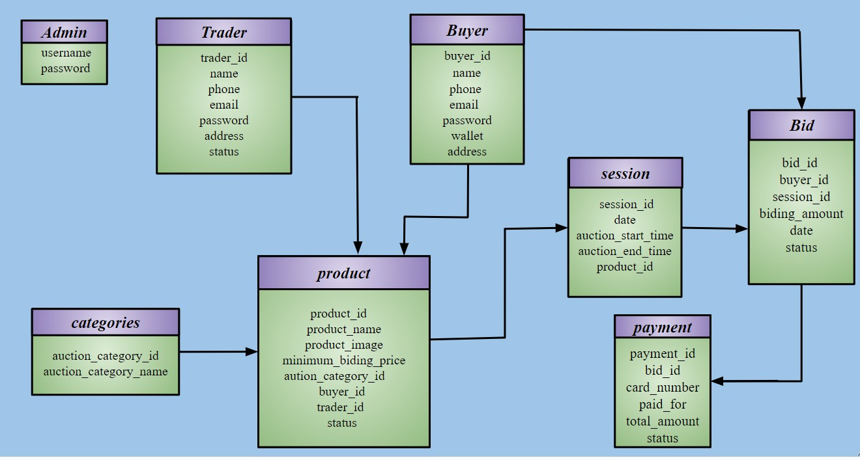

**Database collection:-**

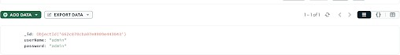**Snippets:- Admin:-**

**Bid:-**

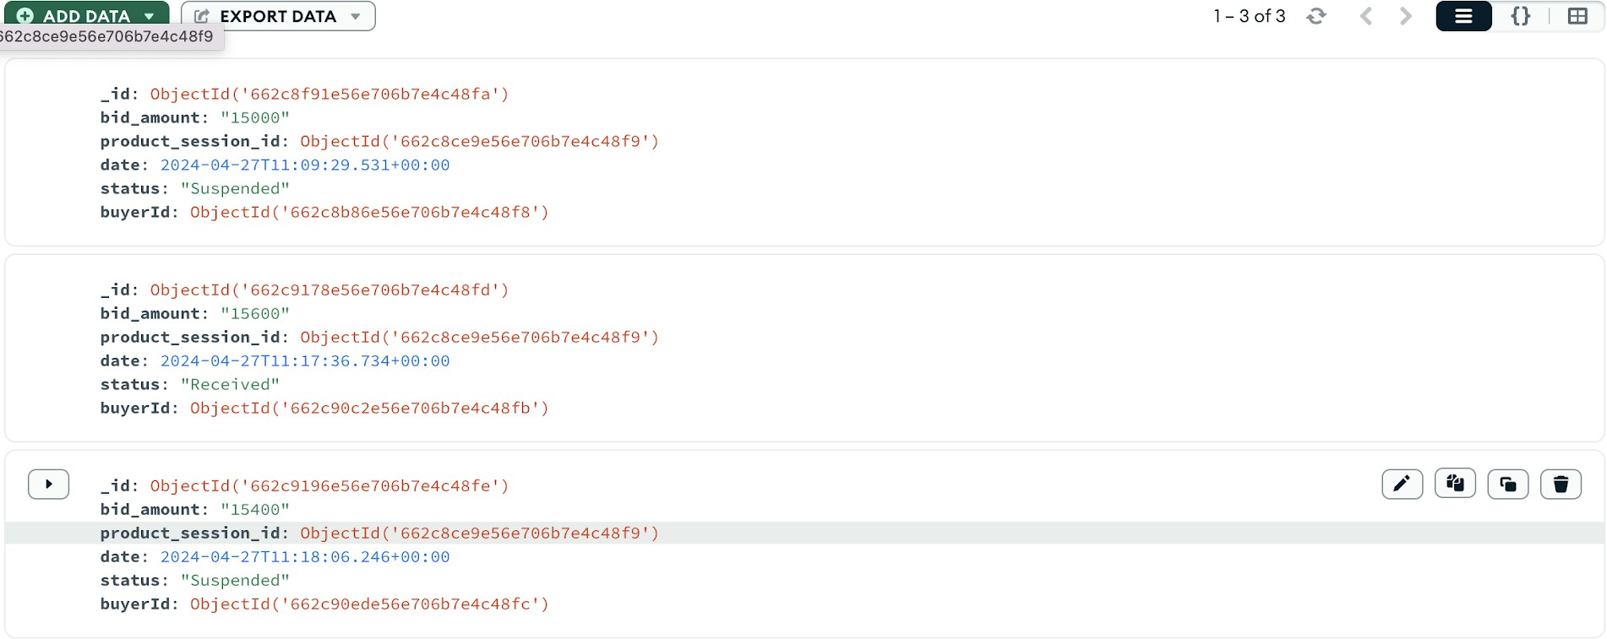

**Buyer:-**

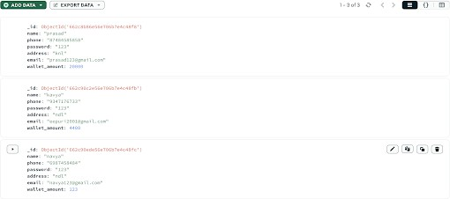

**Category:-**

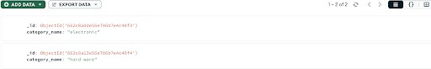

**Payment:-**

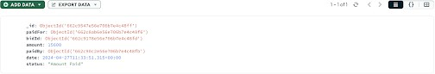

**Product:-**

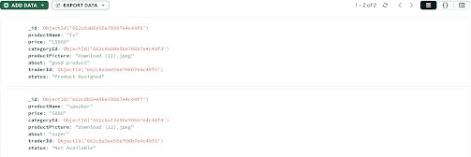

**Session:-**

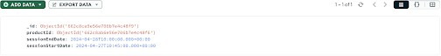

**Traders:-**

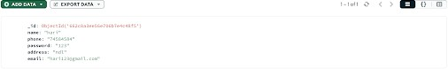

**Website Home page;-**

It is the homepage of an online auction website. We have three modules. admin, trader and buyer.

# Admin login page;-

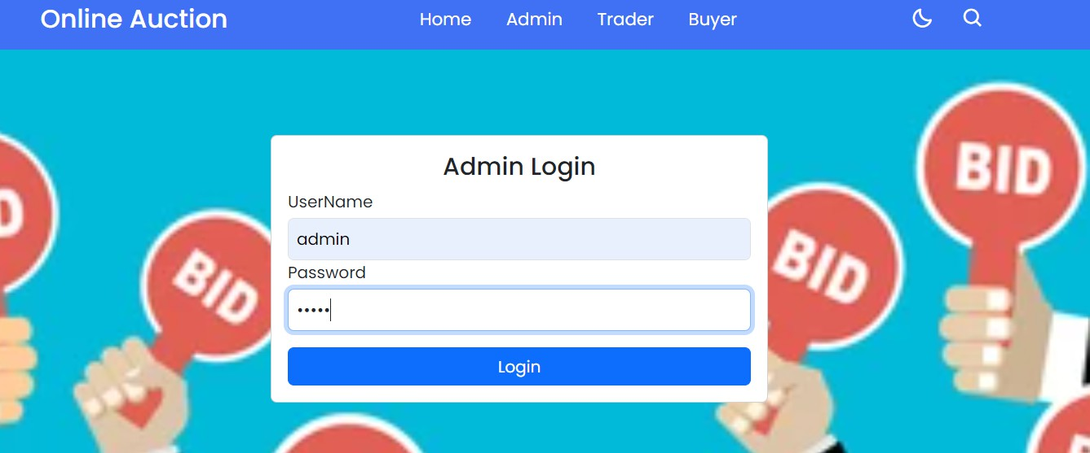

It is an admin login page,the admin can login into the website with predefined login credentials like user name and password.

**Admin Trader Approval** :- Admin is going to approve newly register Traders.

# Admin add category:-

The admin can login into the website with predefined login credentials. After that, the admin can add the category name by clicking the add category button in the website.

**Admin Bidding Commission :-** Admin can modify the percentage of the product depending on the bidding .

The admin will view and verify the added products by the trader and approve the products by clicking the approve product button in the website.

# Admin view all bidding:-

The admin can view all the biddings by clicking the biddings button in the website.

# Trader Registration page:-

This is the Trader registration page of the website. Before login into the website the trader must be registered with their name, phone, email, password, address and by clicking on the add button then trader can,register,into,the­,website.

# Trader Login page:-

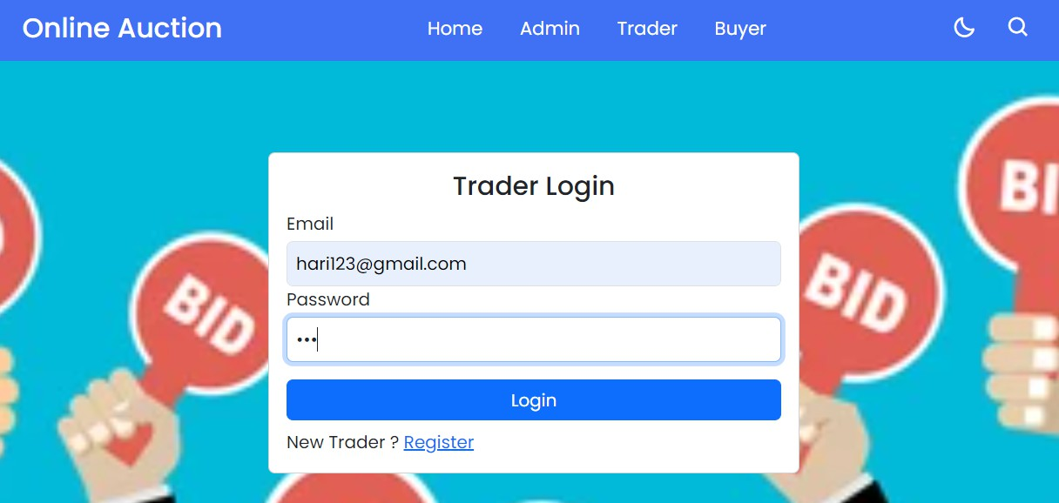

The Trader can login into the website with their email and password,by clicking on the login button they will login into the website.

# Trader add products:-

The Trader can add the products into the website by adding the complete details about the products and by clicking on the add product button then the products will be added into the website.

# Trader view products:-

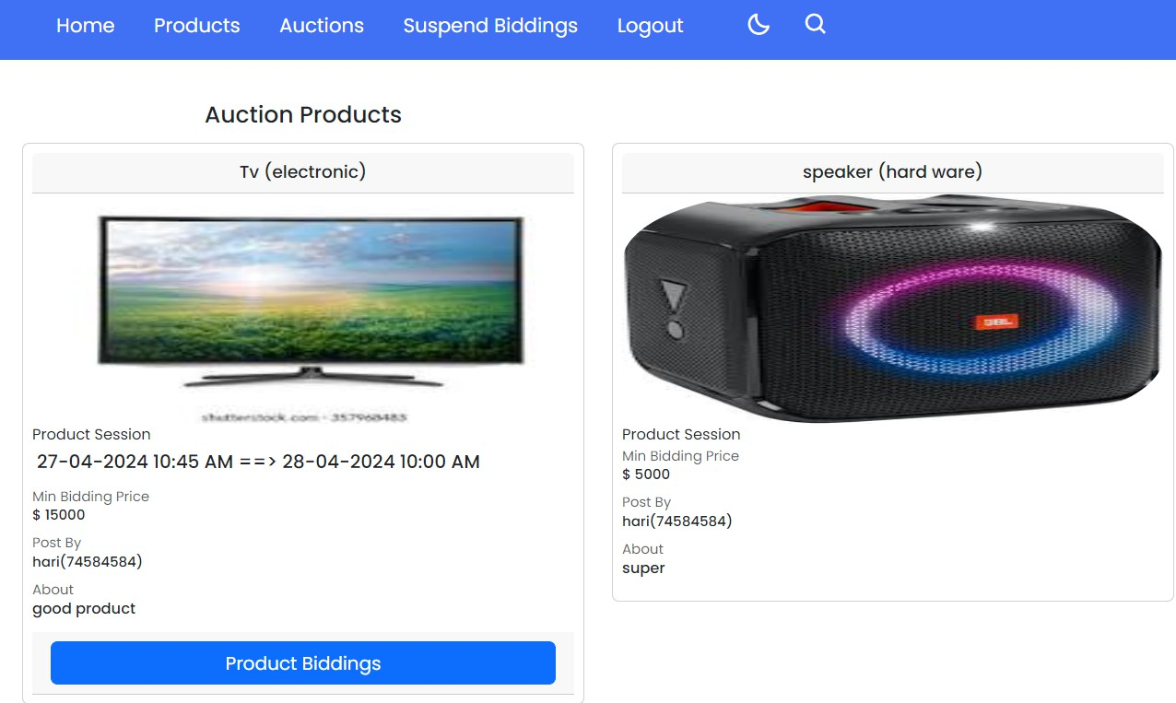

The trader can view the product details like product session, min bidding price, postby and about into the website.

# Trader add bid:-

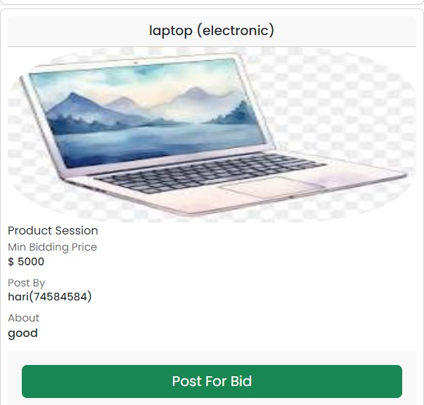

If the admin approves the product then the trader login in to the website. After that he posts the product for bid by clicking the post for bid button.

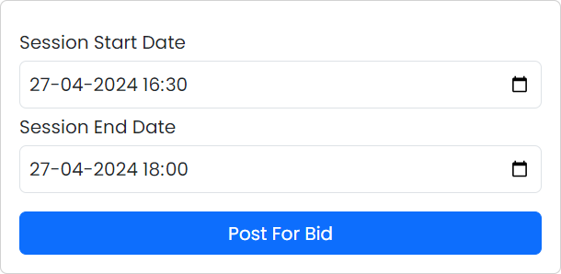

The Admin will add the session start date and session end date by clicking the post for bid button in the website.

# Trader view bidding:-

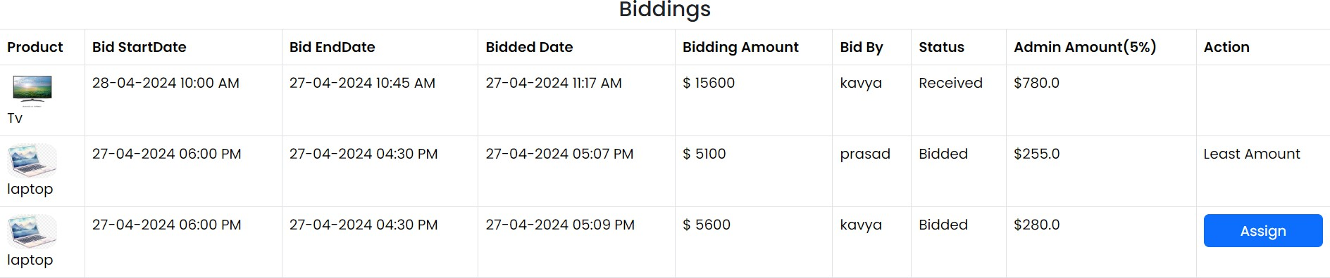

The trader view all bidding and the product will be assigned to the highest bidder of the buyer by clicking the assign button in the website

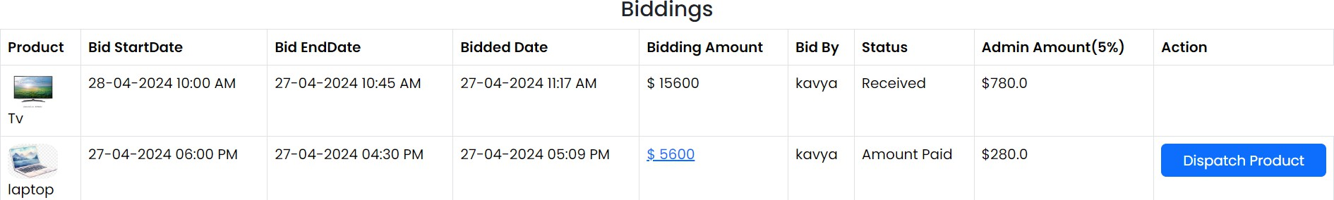

After assigning the product when the buyer pay the amount then the status will changes as a dispatch product

# Buyer Registration page:-

This is the buyer registration page of the website. Before login into the website the buyer must be registered with their name, phone, email, password, address and by clicking on the add button then the buyer can register into the website.

# Buyer Login page:-

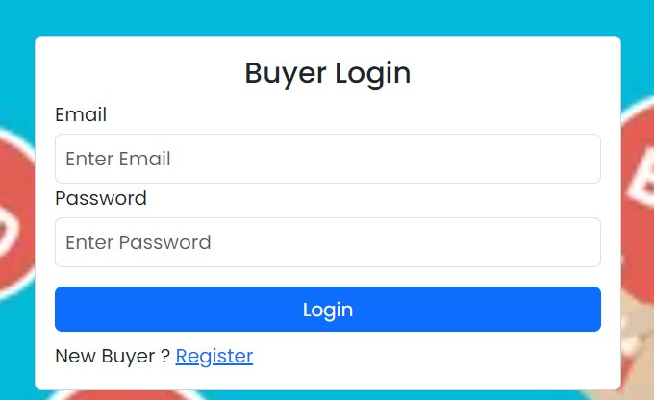

The buyer can login into the website with their email and password,by clicking on the login button they will login into the website.

# Buyer search product:-

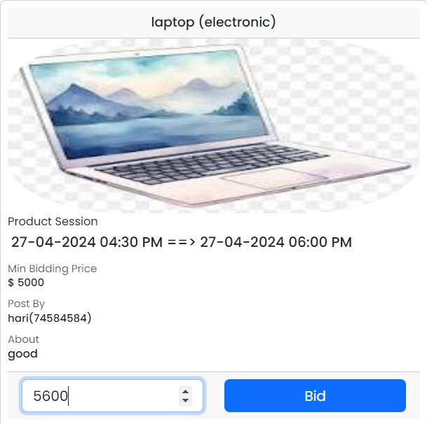

After login in to the website then the buyer can see the products and add the amount by clicking the bid button in the website.

# Buyer view auction:-

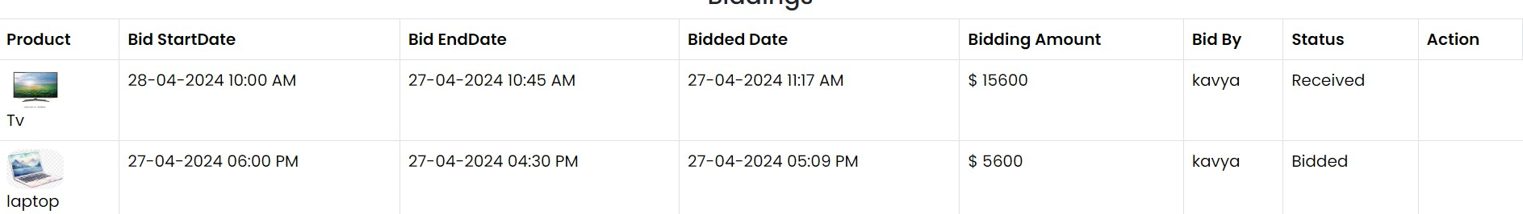

The buyer can view the auction after clicking the bid button on the website.

# Payment:-

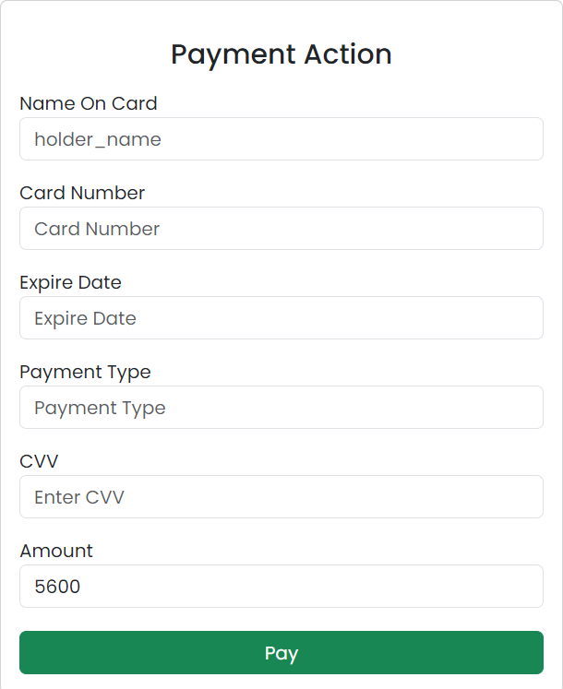

After assigned the product then the buyer will pay the amount it contains the name on card, card number, expiry date, payment type, cvv, amount by clicking on the pay button in the website. Then the status is changed as a paid.